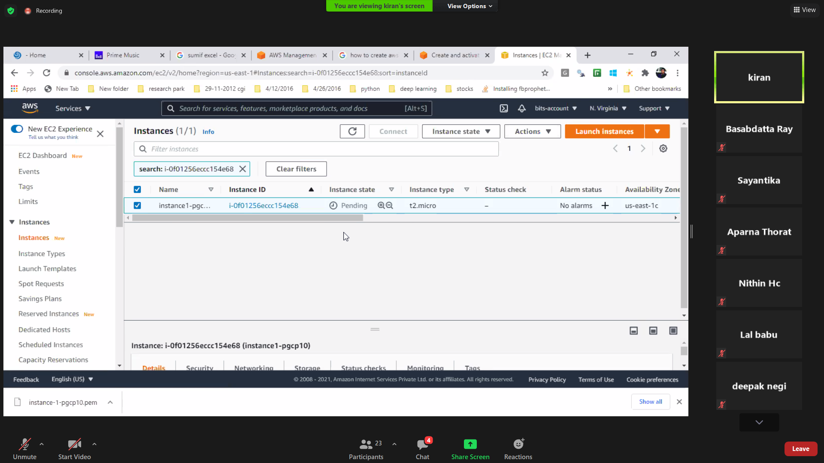

Then connect

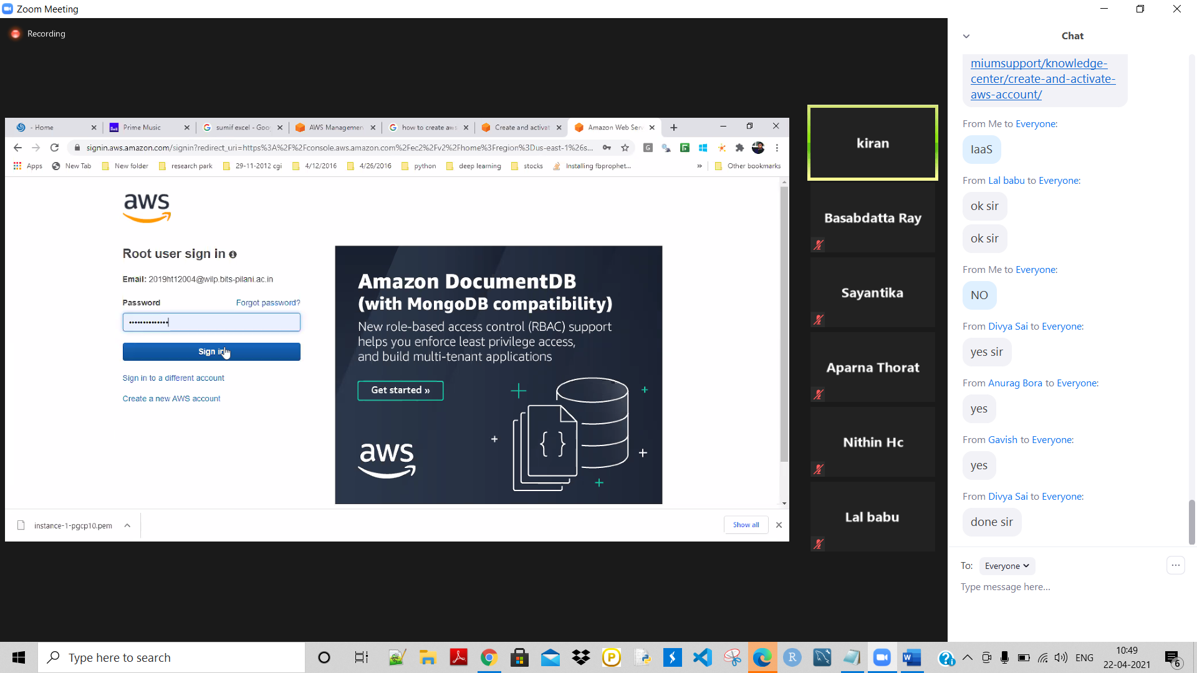

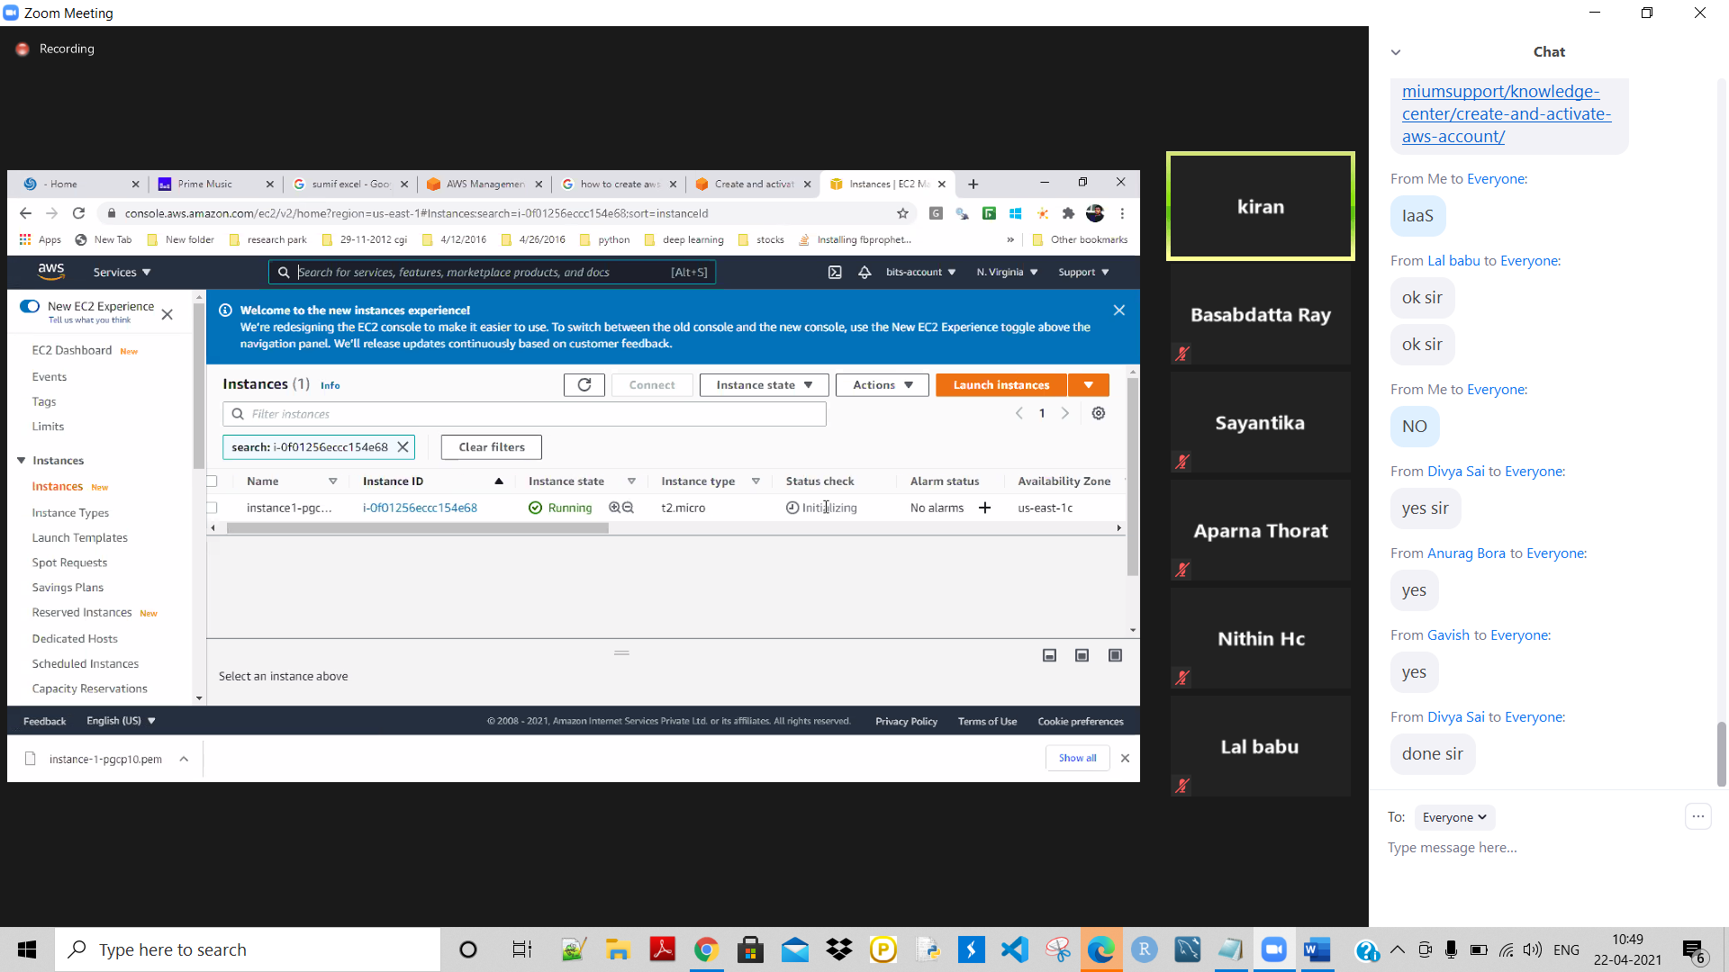

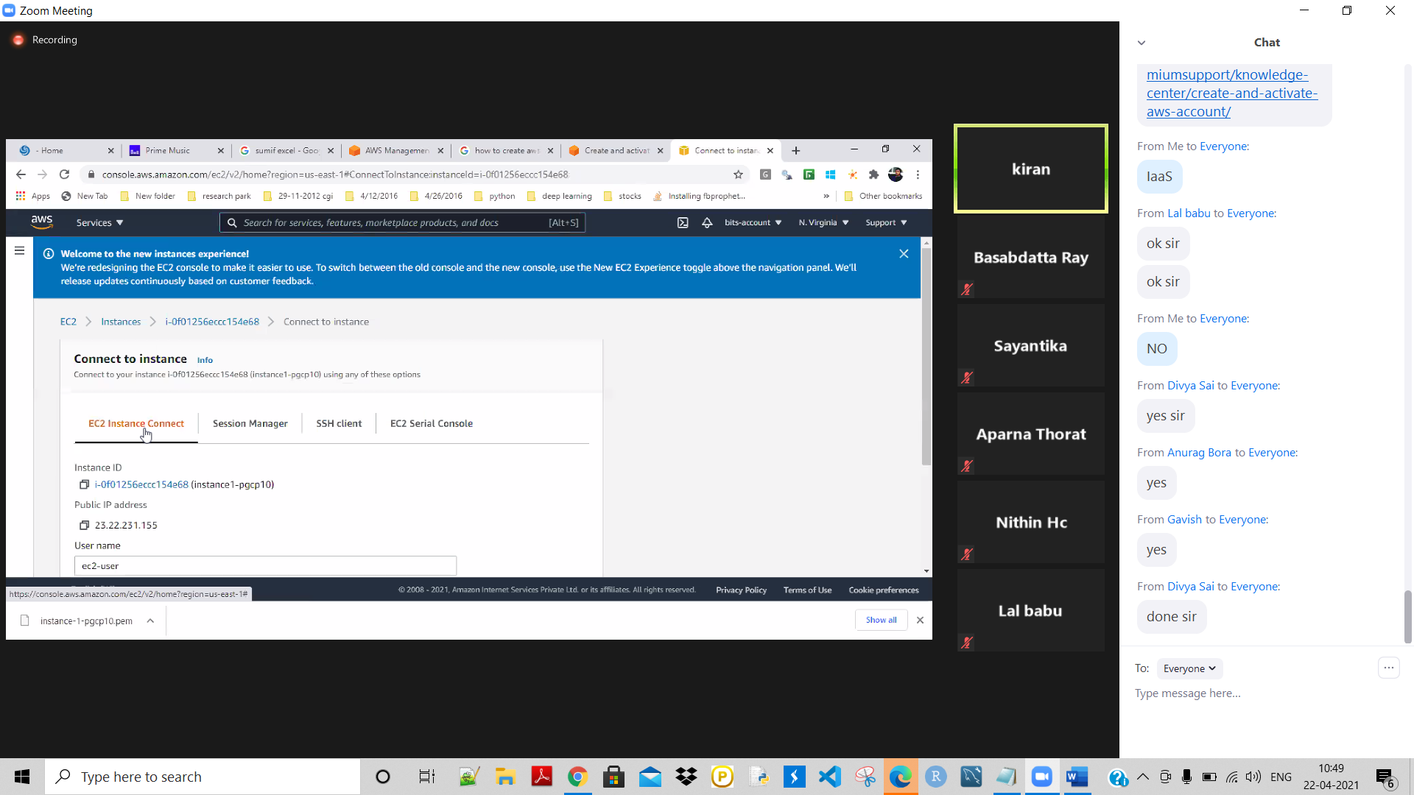

Wait for it to be availeb as it isstill Running

Still Running as we can see from here-

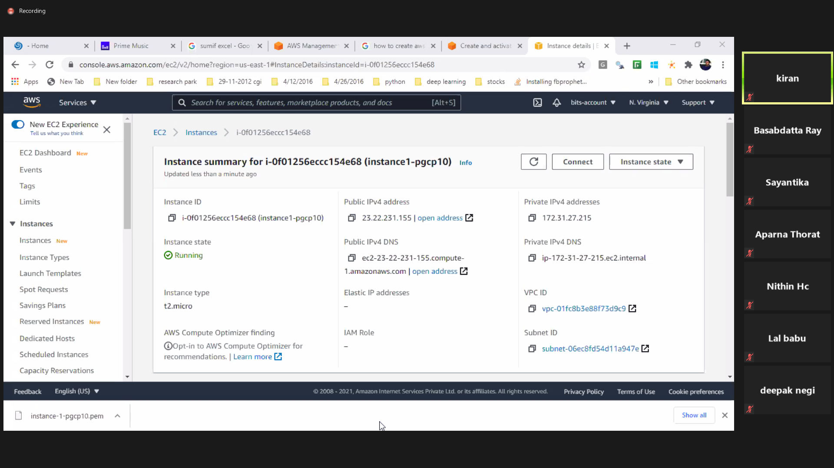

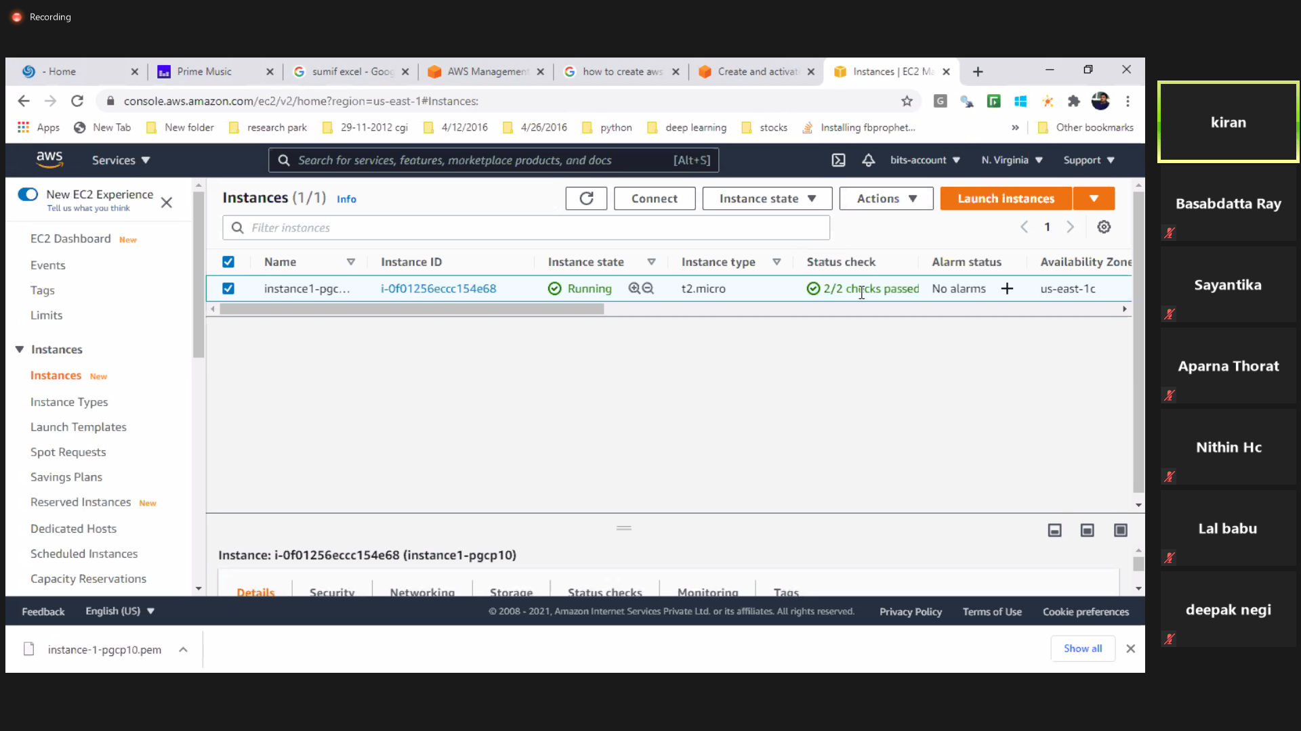

Connect

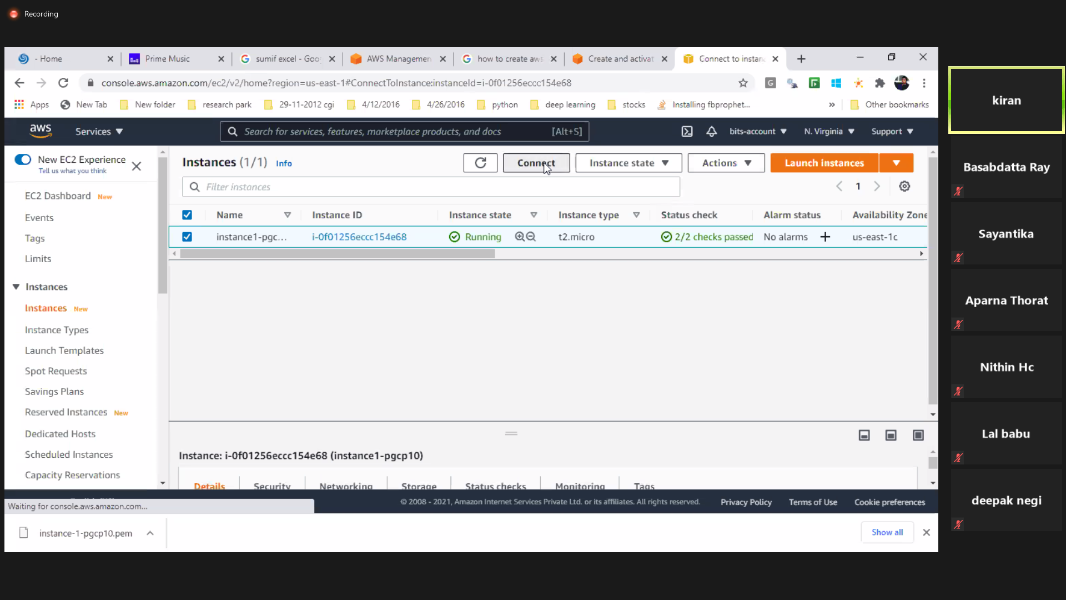

So ready-

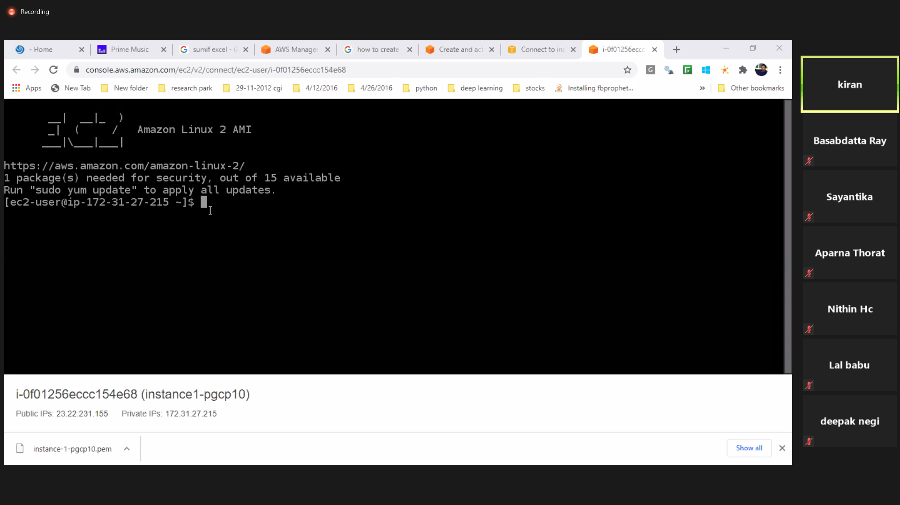

Give ls

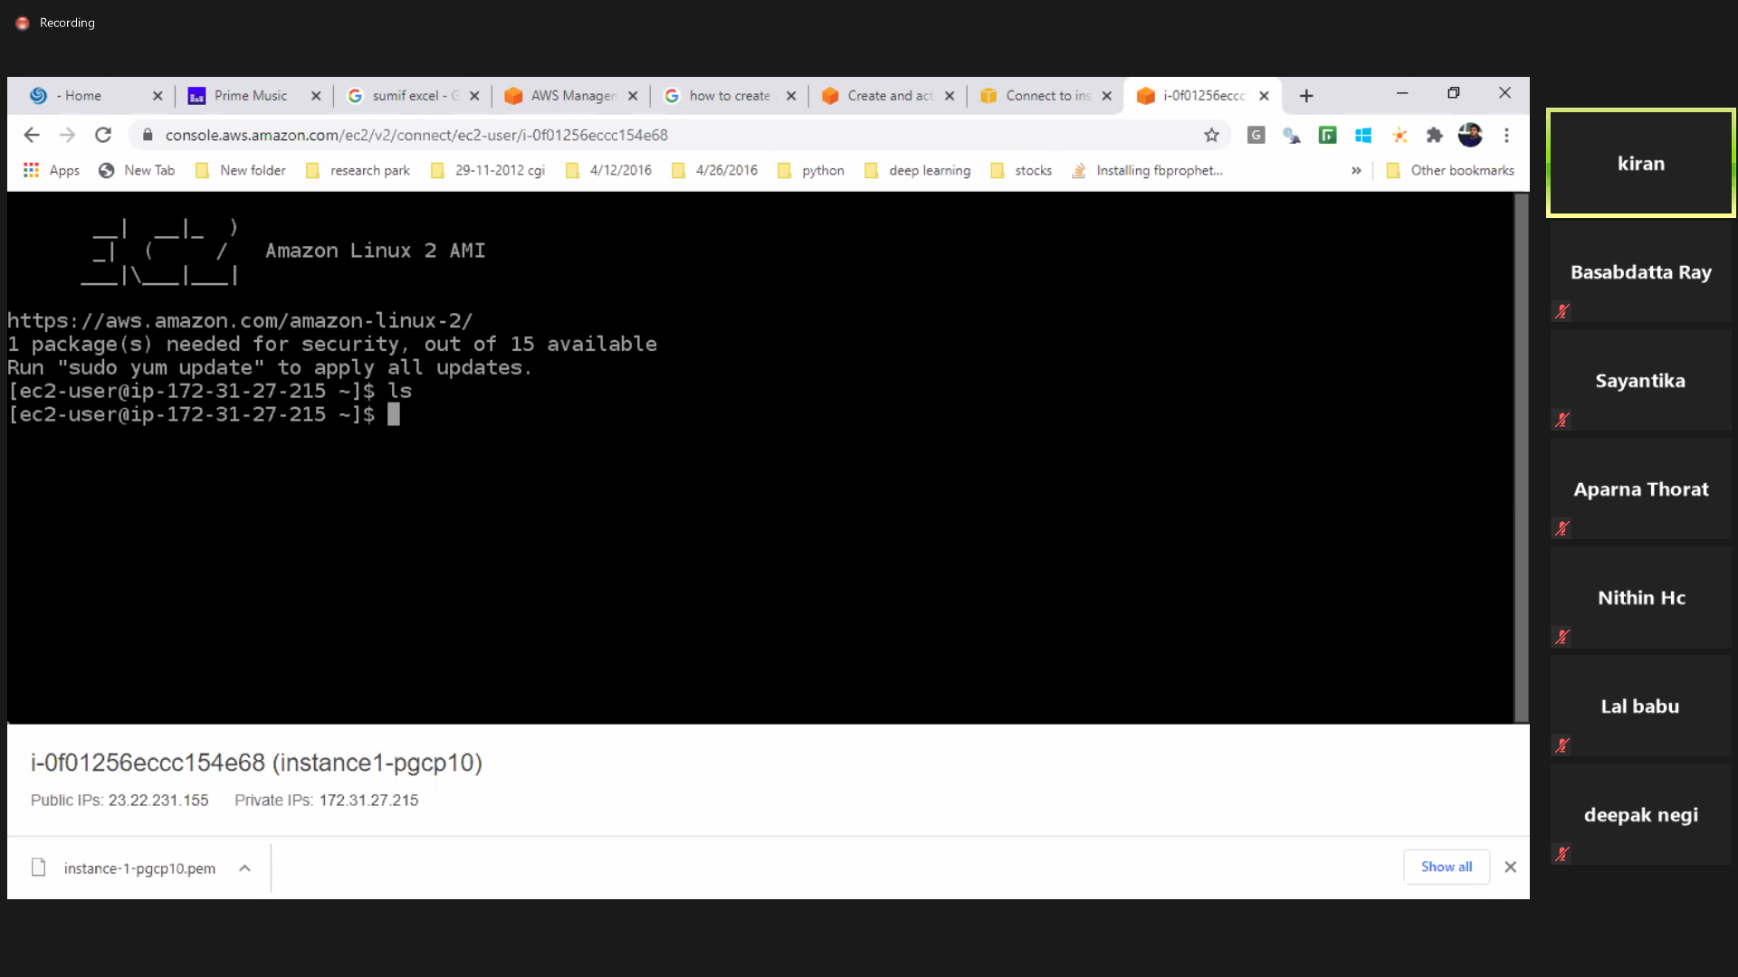

So EC2 Instance is created successfully.

**# Now connect from local machine to the EC2 instance created using SSH Client once the instance has been created successfully. Go to SSH client:**

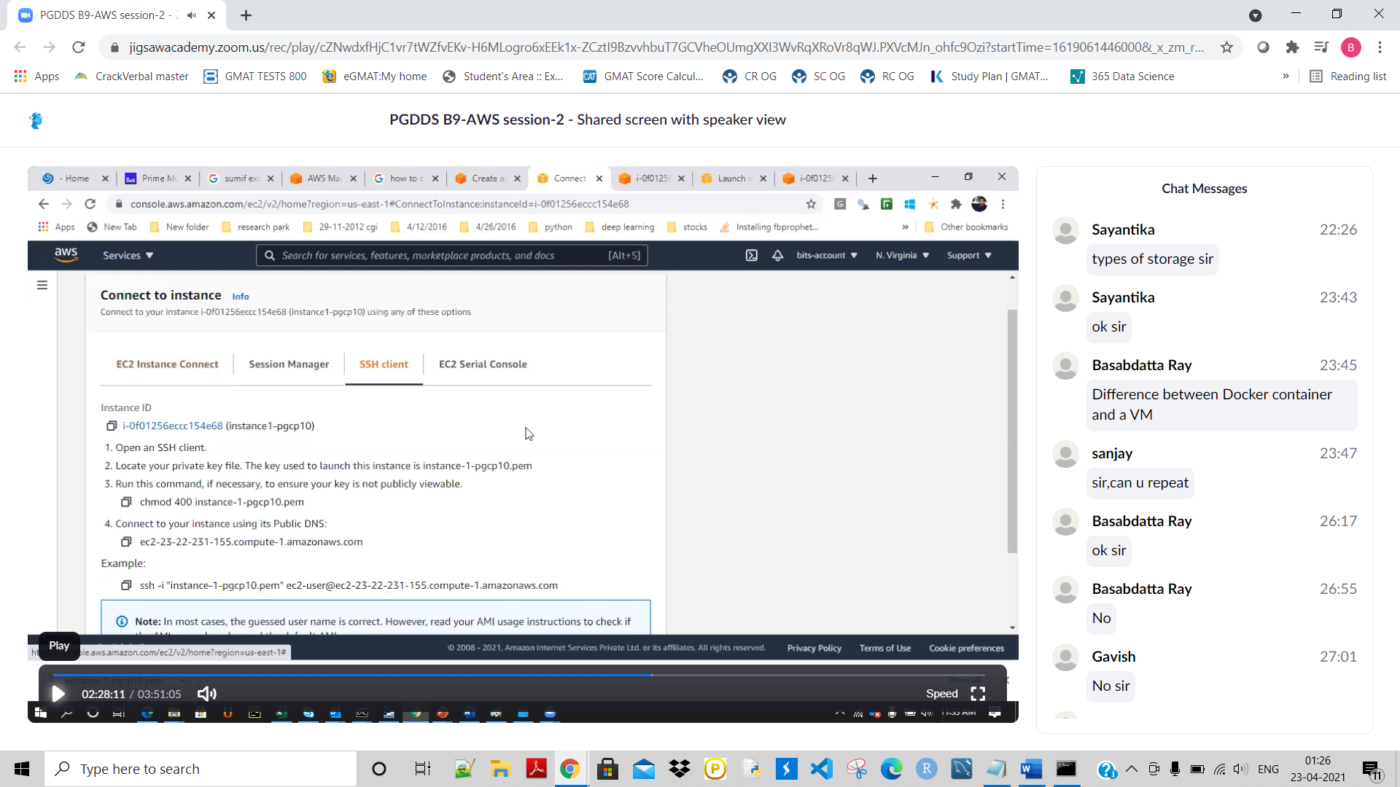

Copy the highlighted command-

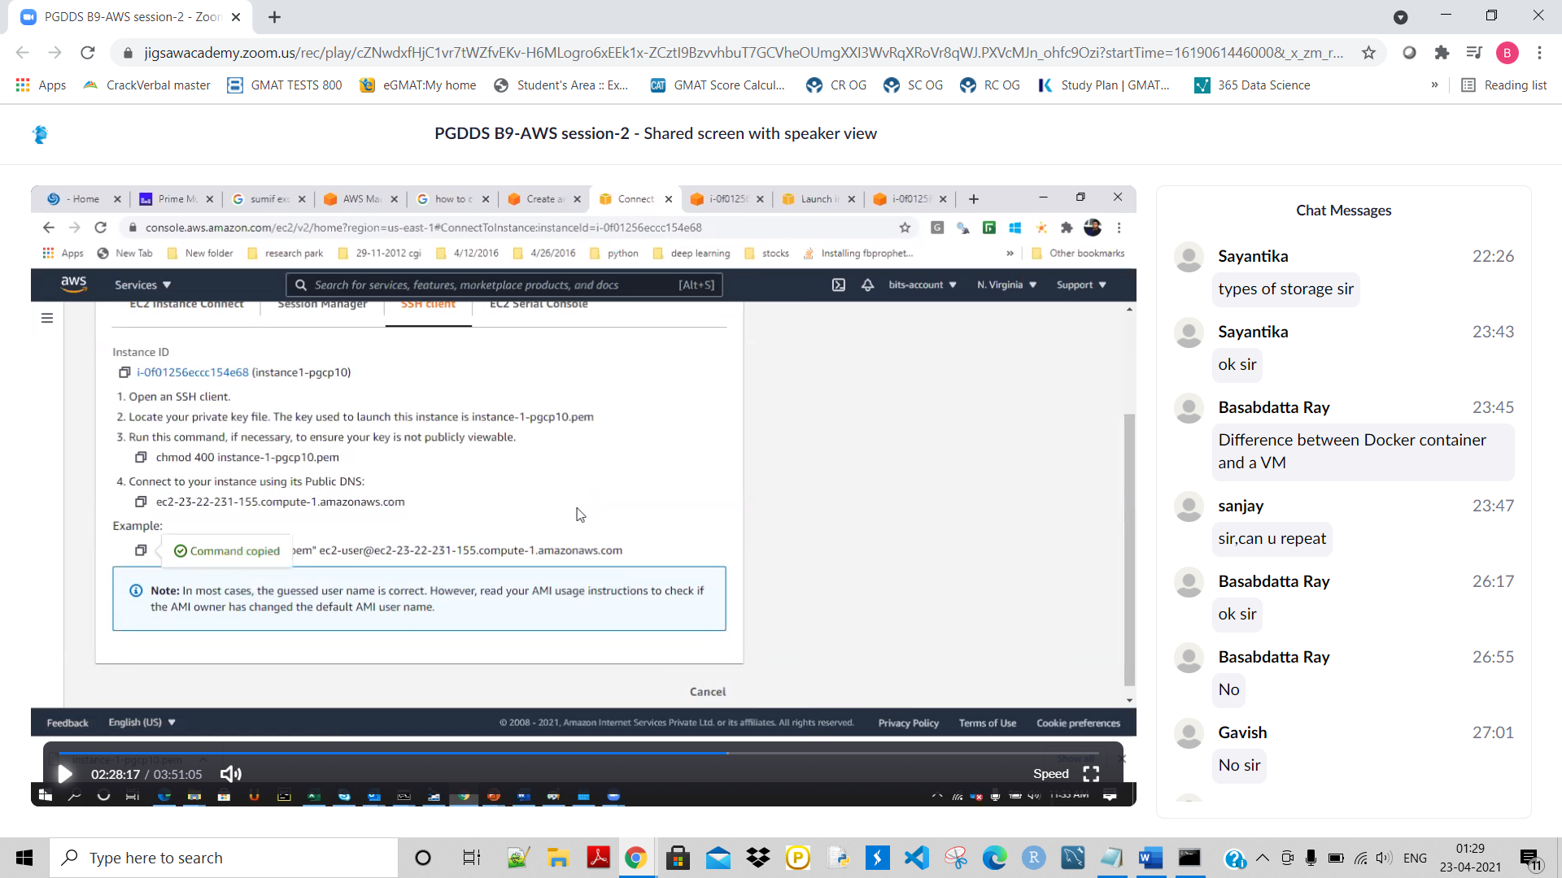

Then go to my command promt.As the key pair file is in downloads folder hence go to downloads by doing cd command-

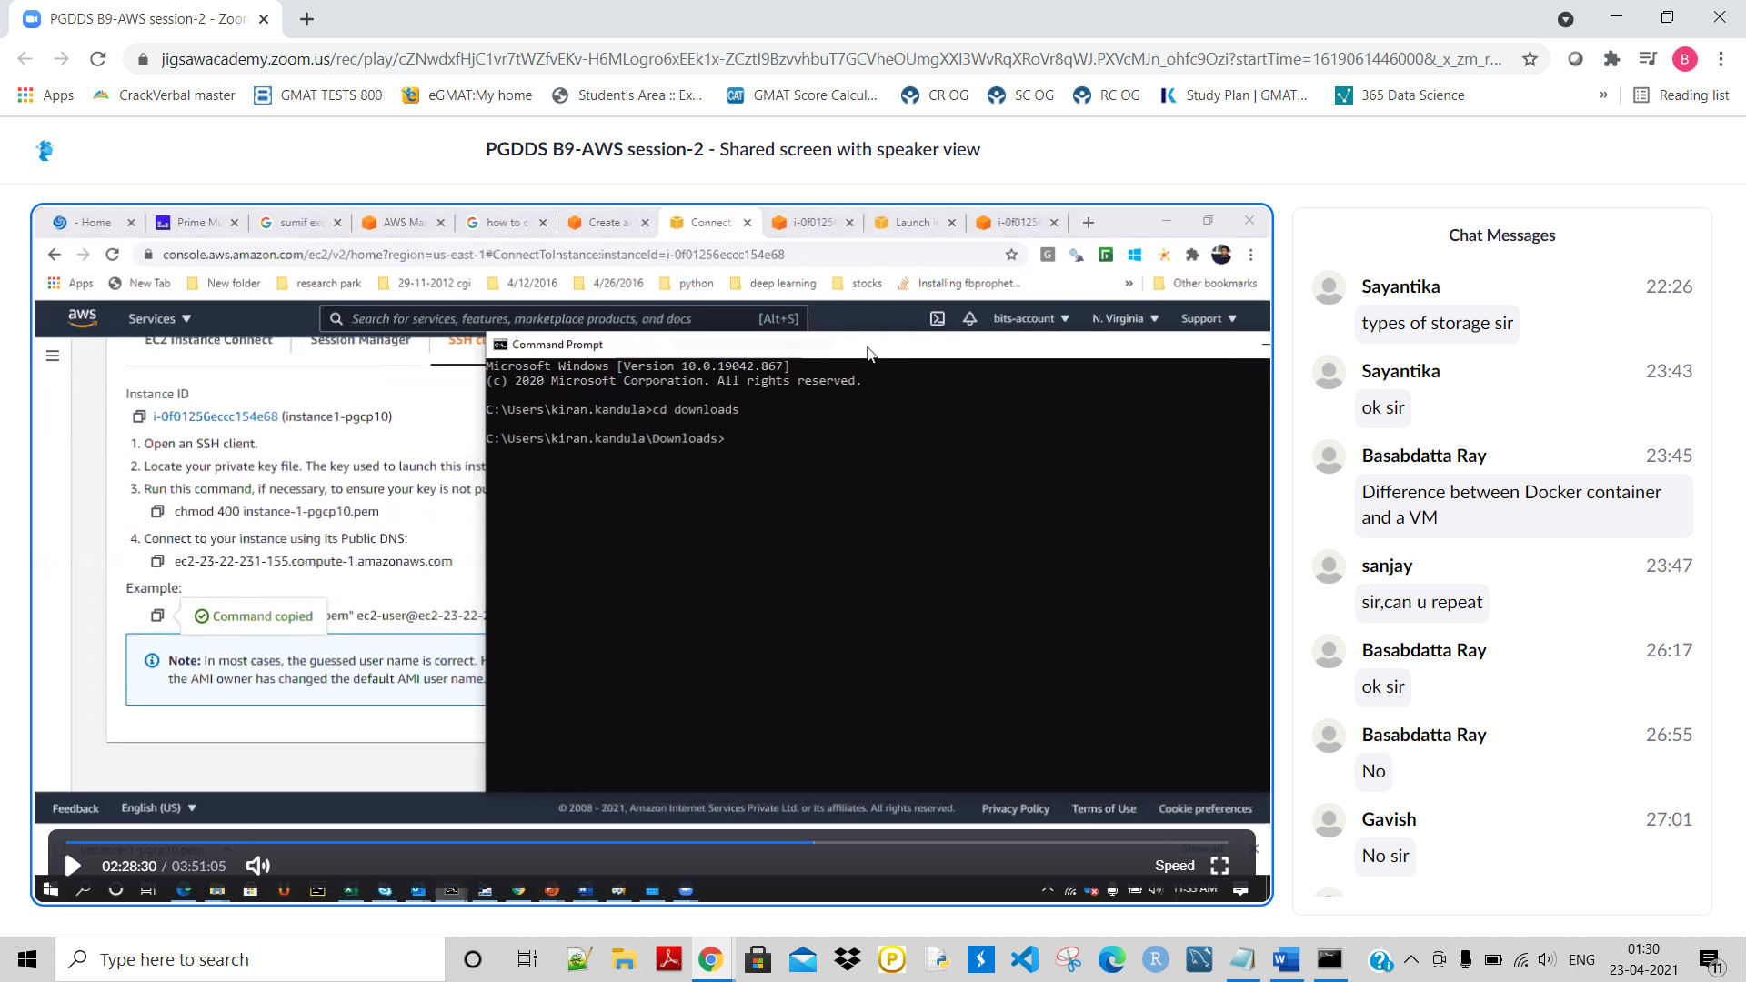

Then paste that copied long command and enter-

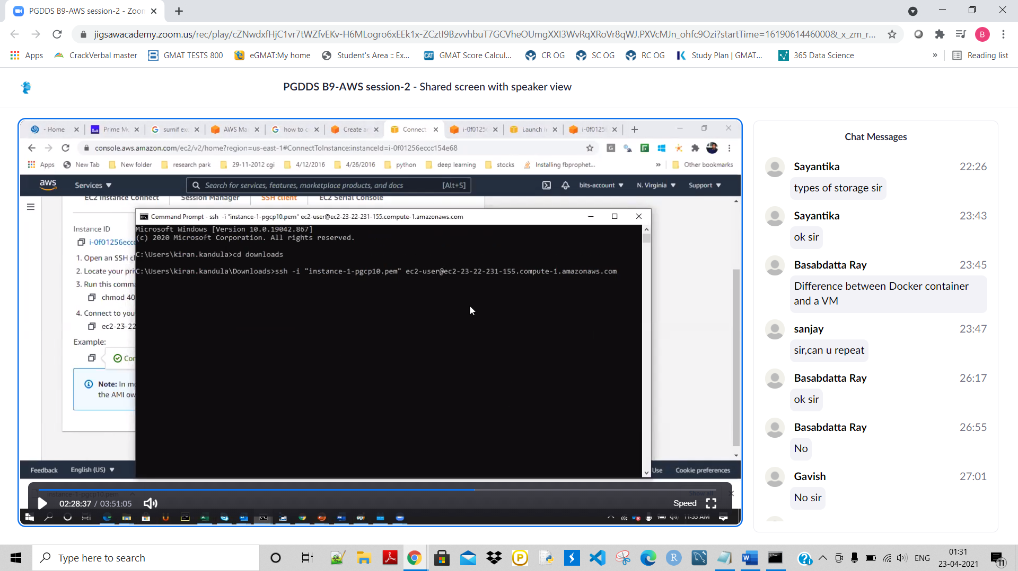

Then give yes and enter. Now the EC2 has been connected from my local system/machine:

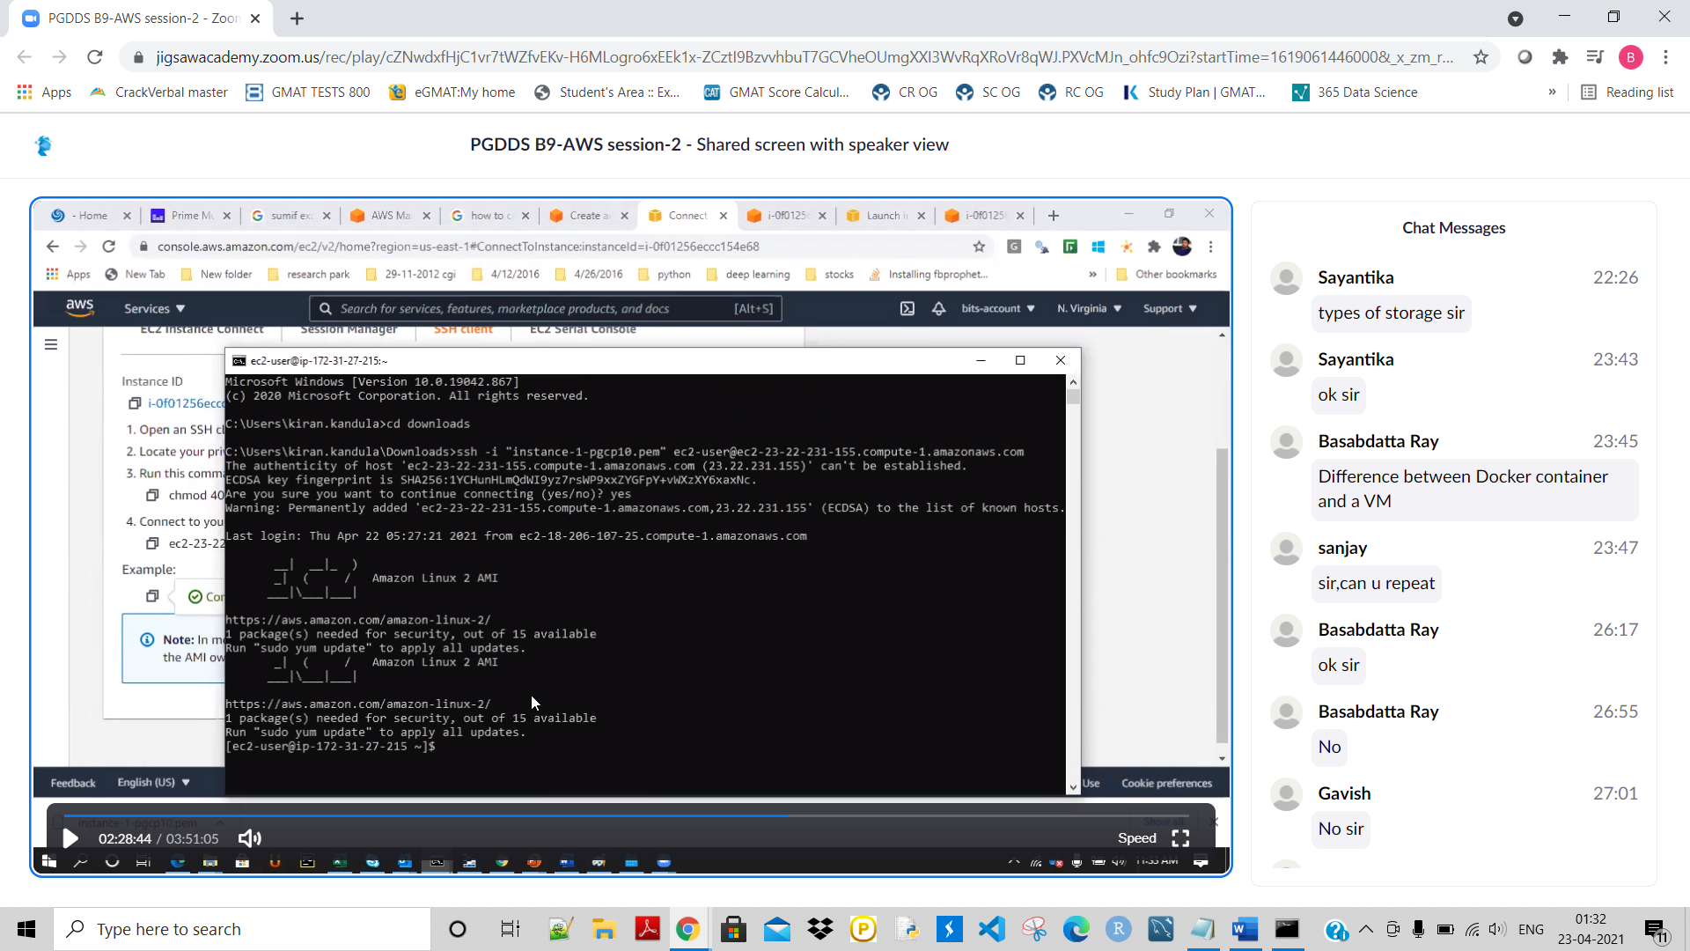

**#IAM Creation – Create 10 users to do a specific project. User creation is done by IAM Dashboard.**

**The task is –**

**1.Create a VM**

**2.Ask those 10 users to modify that VM**

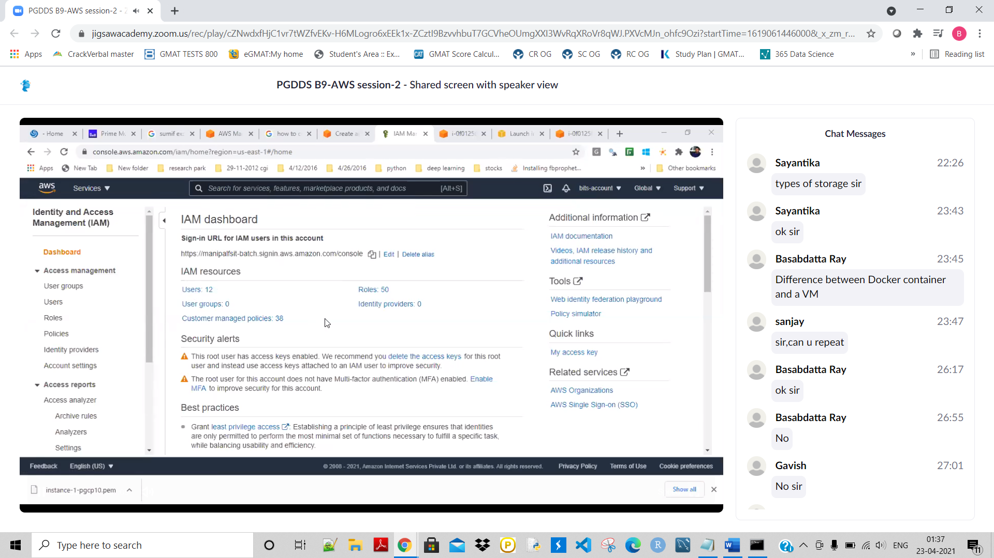

**Click on Users 12:**

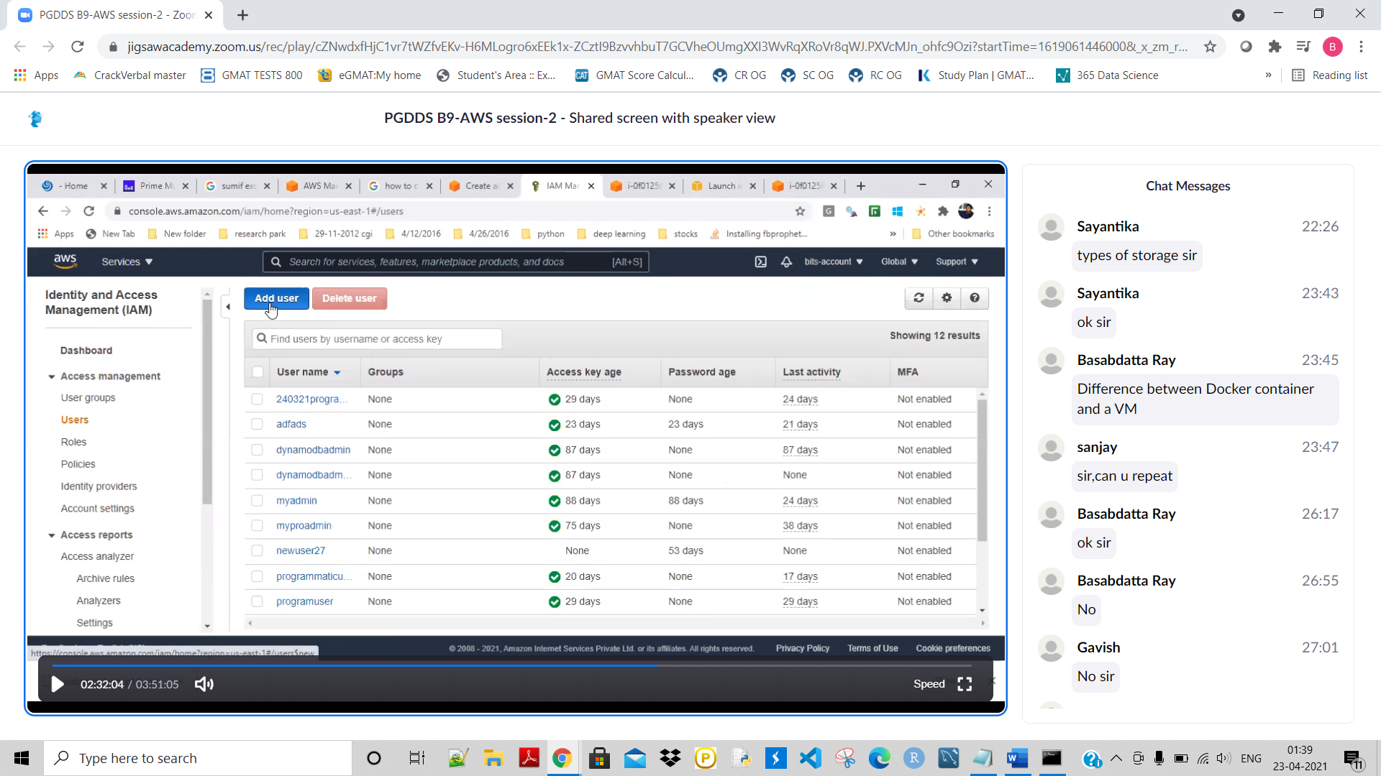

**Click on Add user:**

**Give a name and accsess like :**

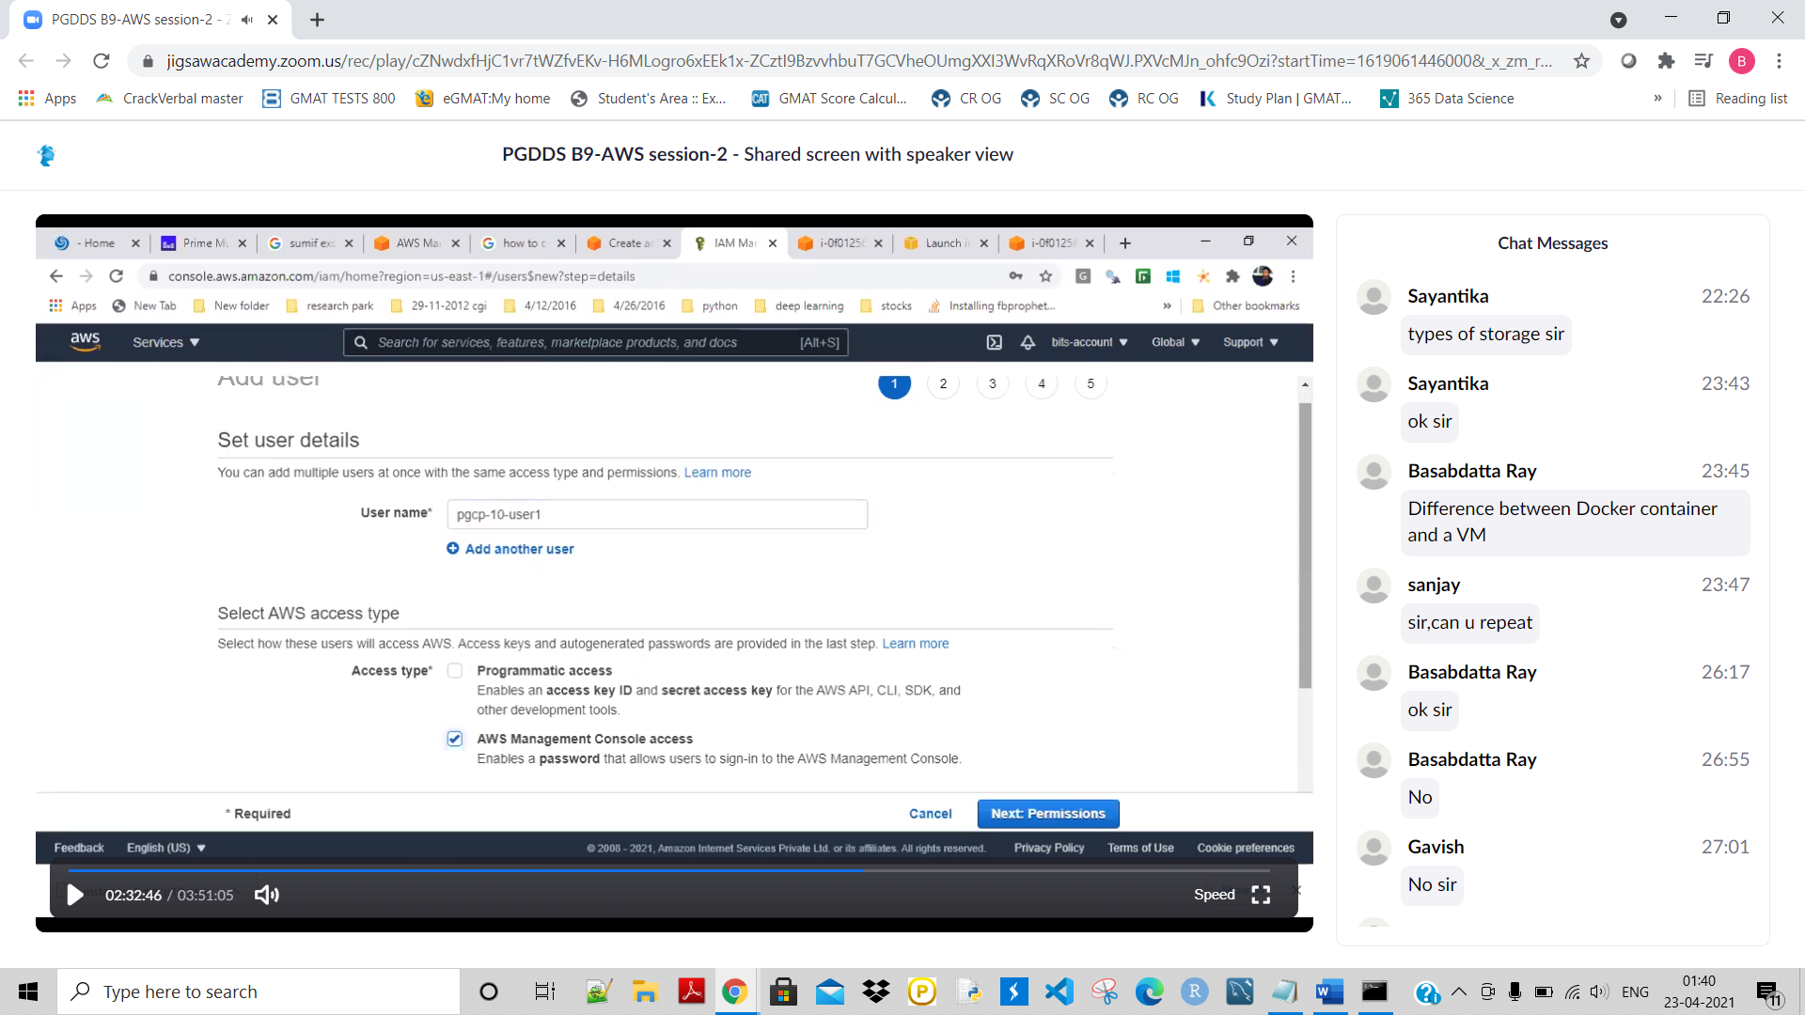

**Give a console password as shown:**

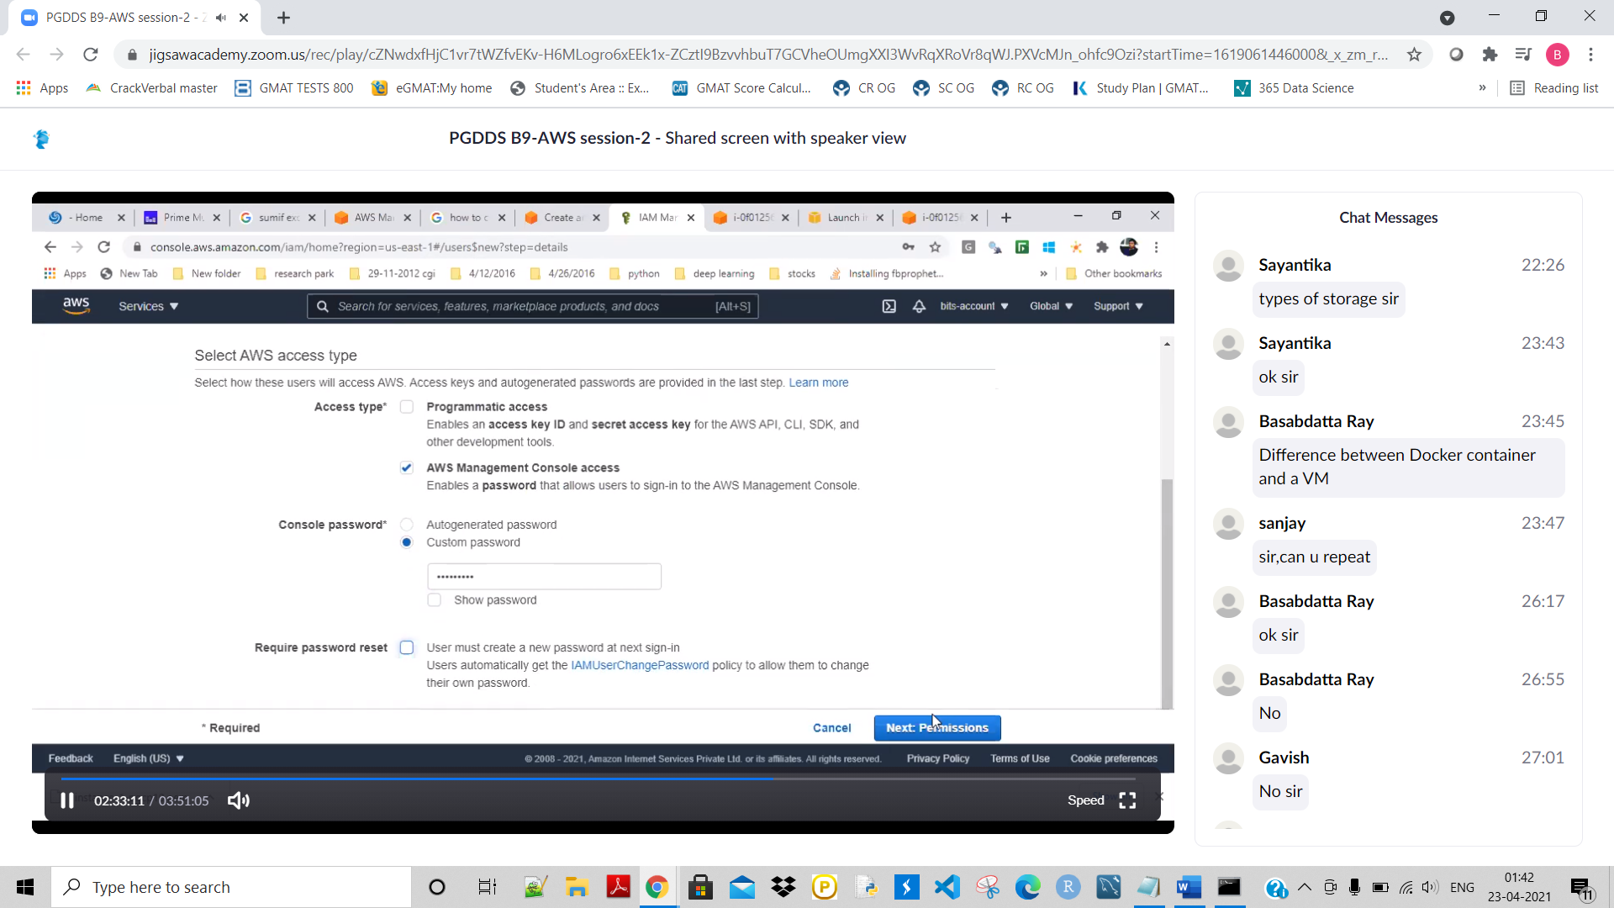

**Now clisk on Next: Permissions:**

**Now here we can give access to the user/user grpoup etc..Give access as selecet below:**

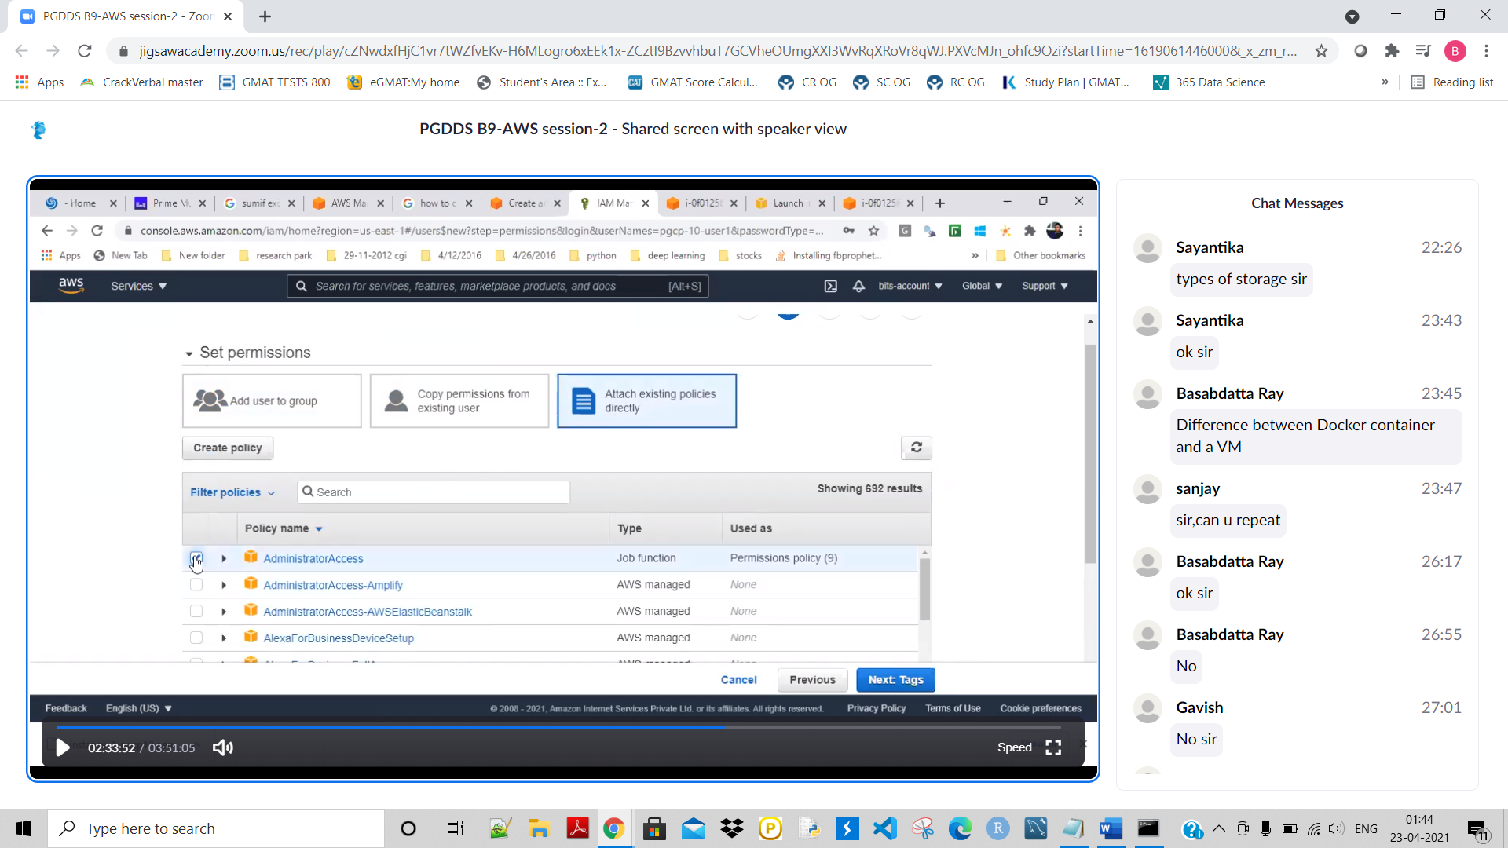

**Next click on next: Tags:**

**Next clisk on next: Review**

**Next clisk on create user:**

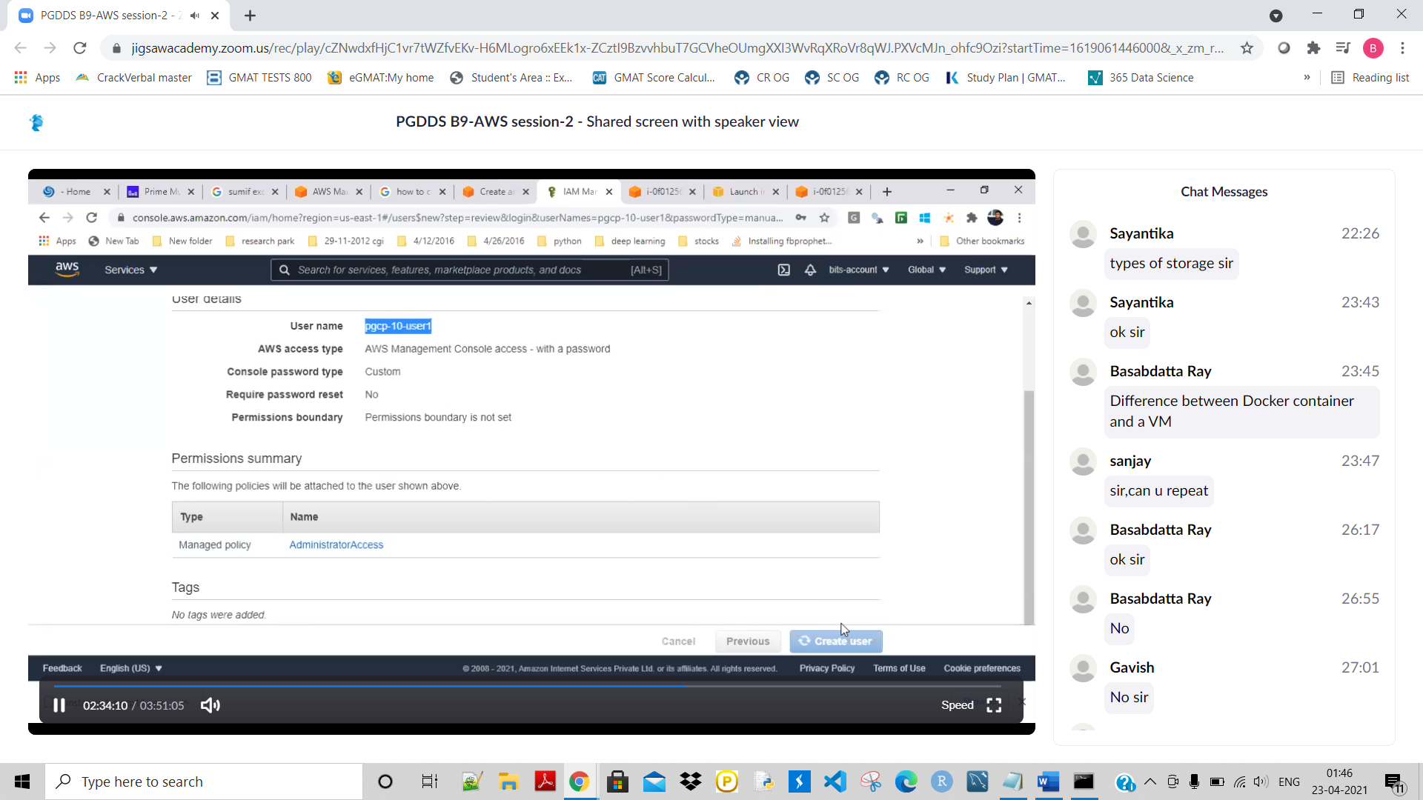

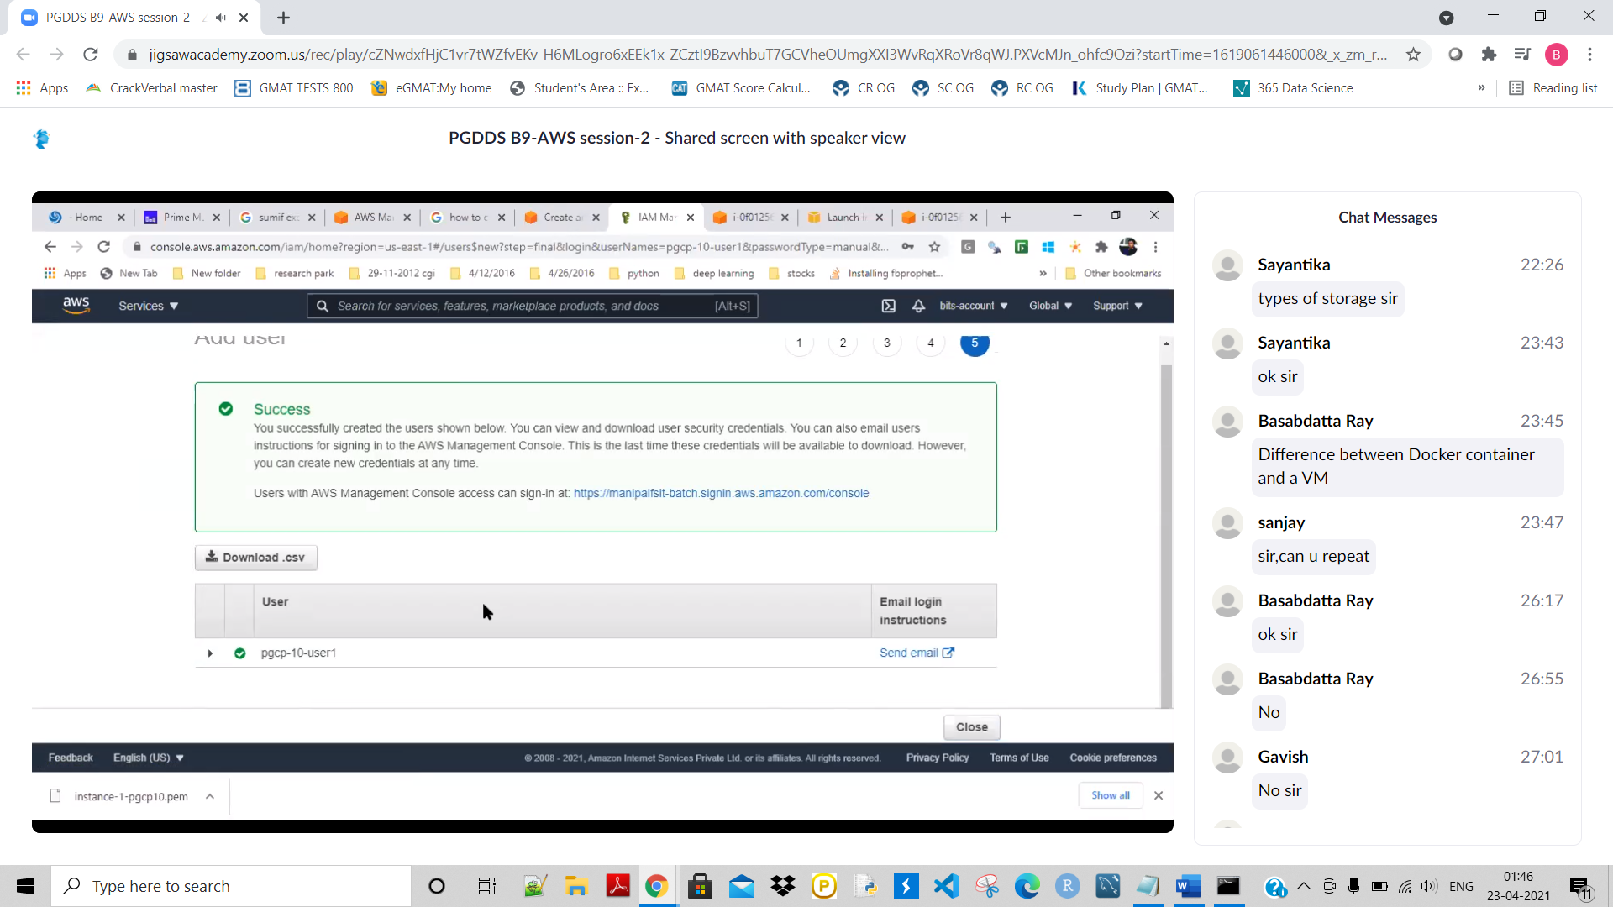

**Now click on the ‘Download.csv’ to save this file file because if we want to connect locally then this will have the access key.**

